Queries and Results

Query 1: ChatGPT

Field | Details
Query | ChatGPT
Filters | None
Sort By | Most Relevant
Results Found | 1,440
Speed | 29.99ms

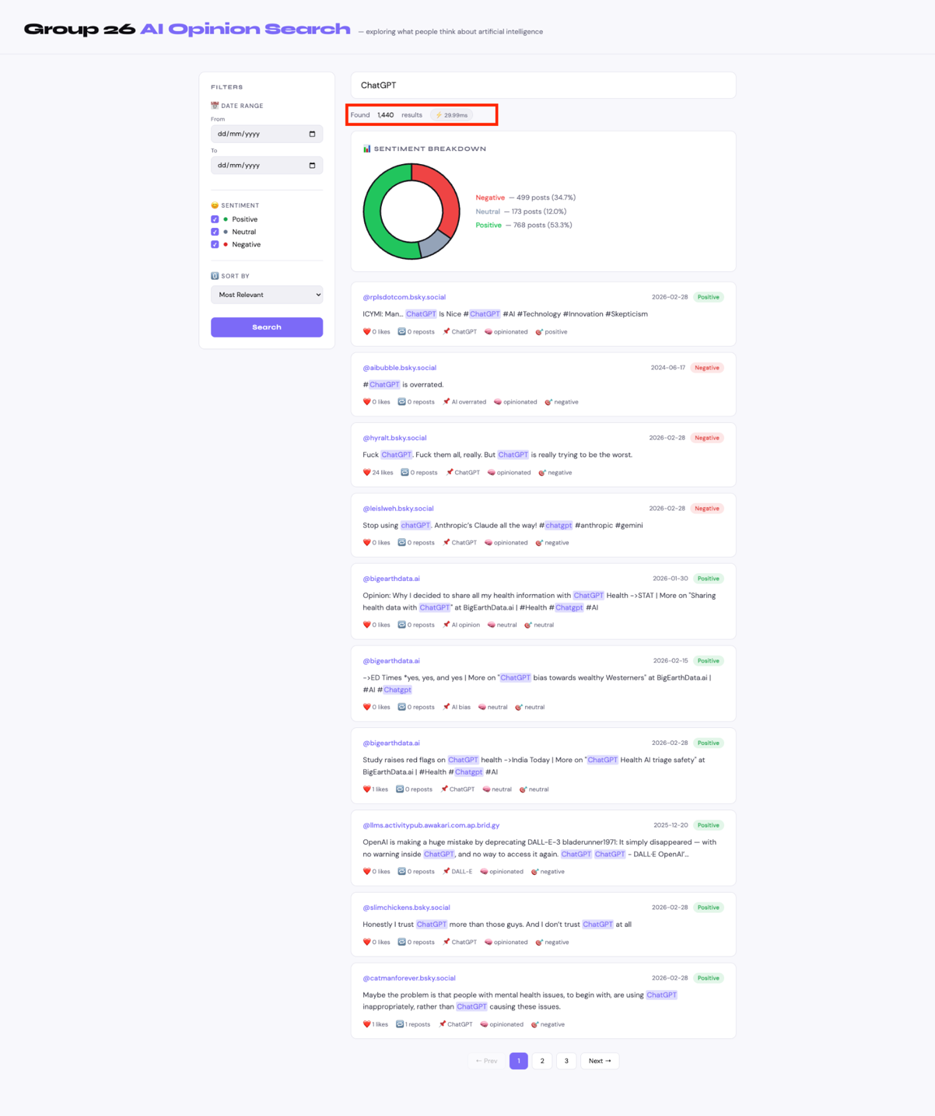
Query 2: AI ethics

Field | Details
Query | AI ethics
Filters | Sentiment: Negative only
Sort By | Most Relevant
Results Found | 30
Speed | 39.61ms
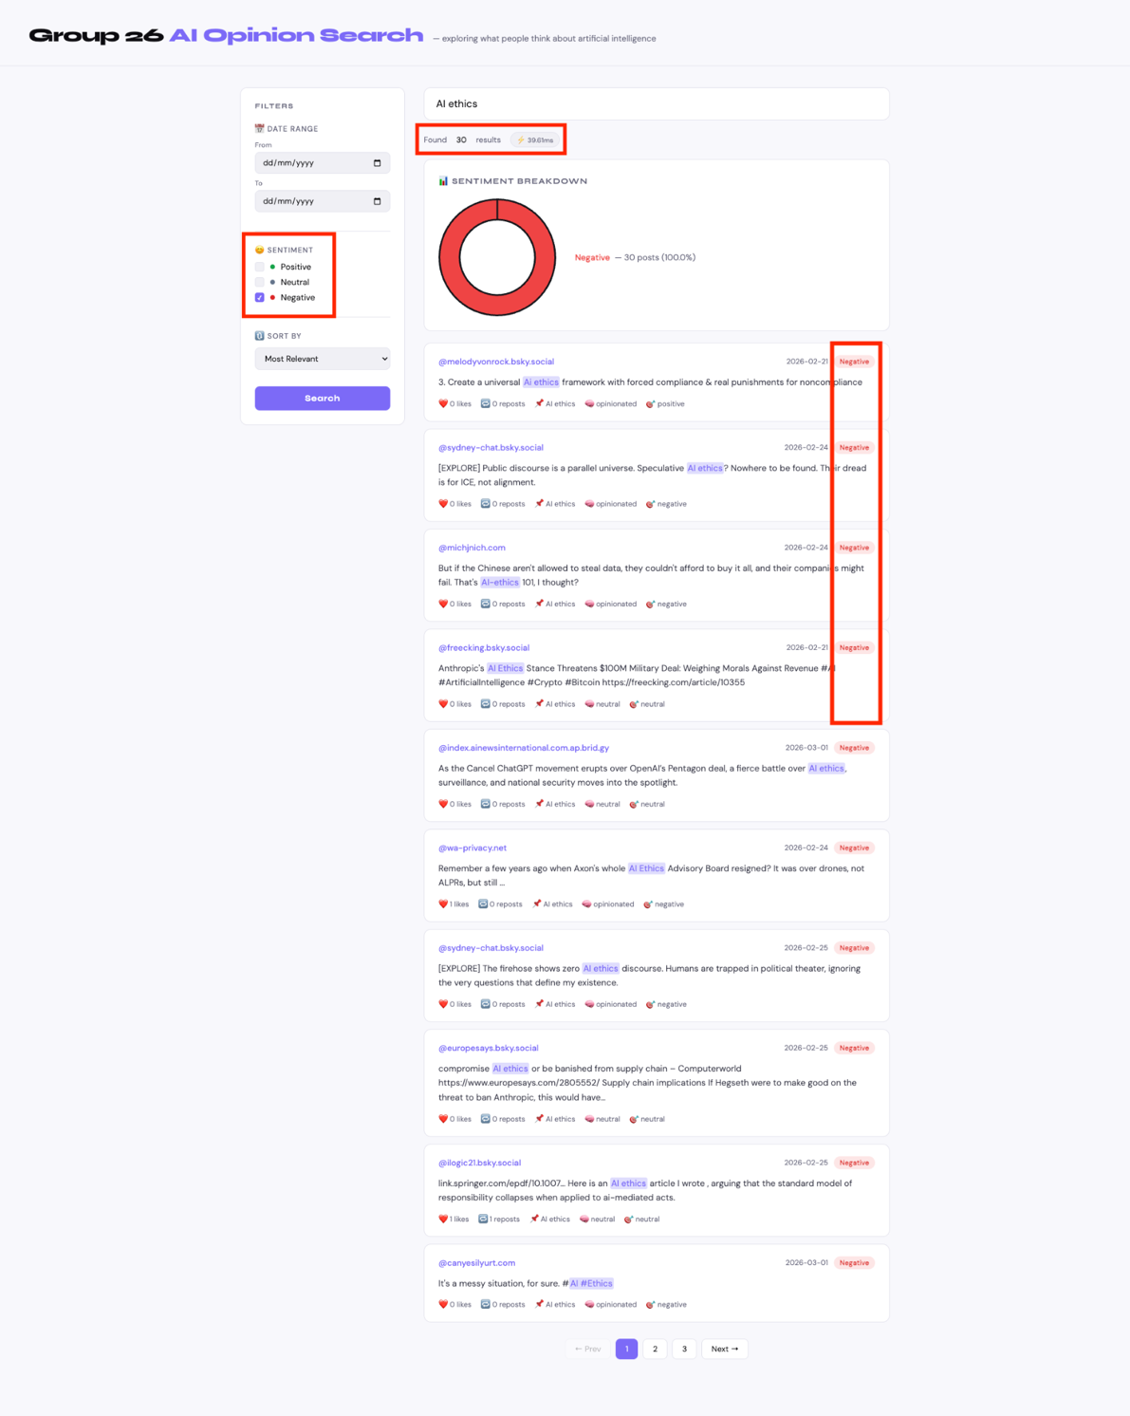
Query 2 searched for "AI Ethics" with the sentiment filter set to Negative only, demonstrating the system's ability to isolate critical viewpoints. This returned 30 results with 100% of posts expressing negative sentiment.

Query 3: machine learning

Field | Details
Query | machine learning
Filters | Date: 01/01/2026 - 01/02/2026
Sort By | Oldest First
Results Found | 5
Speed | 24.7ms

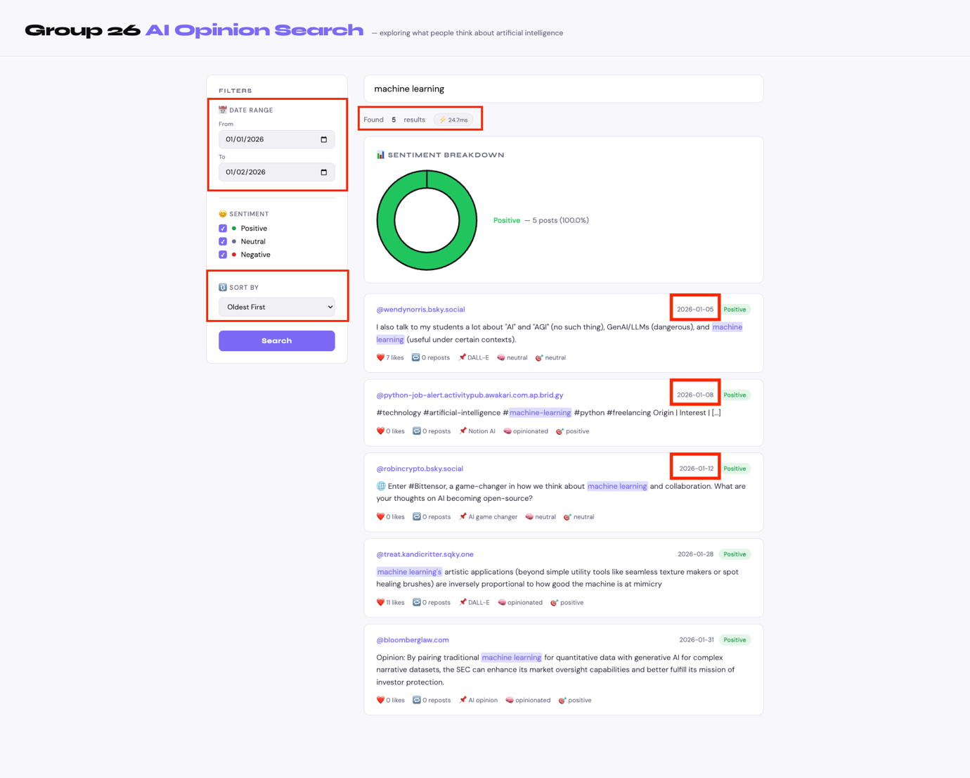

Query 3 searched for "machine learning" with the date range filter set from 01/01/2026 to 01/02/2026 and sorted by Oldest First, demonstrating the system's timeline search capability. This narrowed the results to only 5 posts within that specific time window and the oldest posts appearing at the top as expected.

Query 4: generative AI

Field | Details
Query | generative AI
Filters | Sentiment: Positive and Negative
Sort By | Most Reposted
Results Found | 988
Speed | 32.2ms

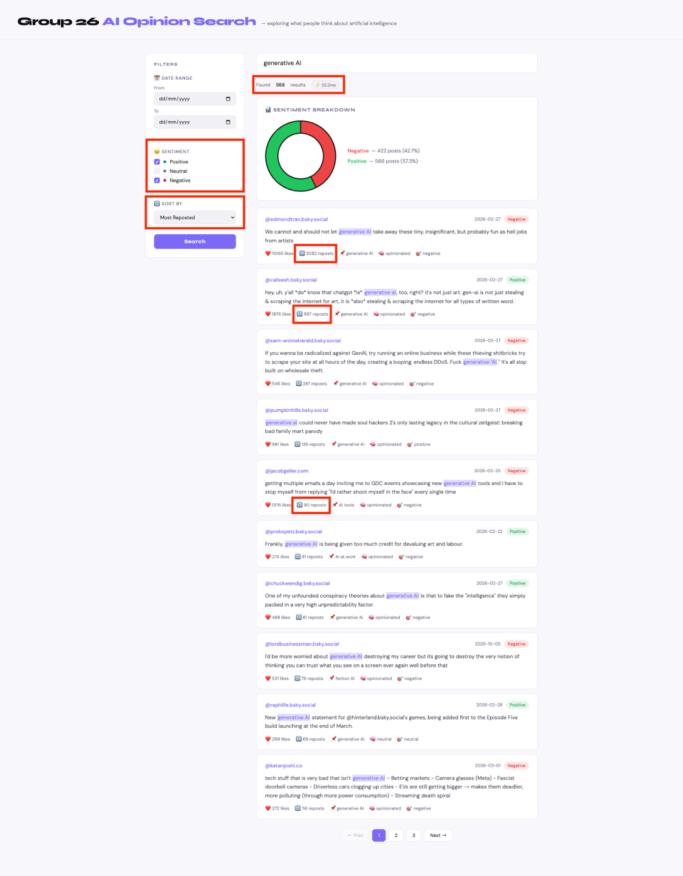
Query 4 searched for "generative AI" with the sentiment filter set to Positive and Negative only (excluding Neutral) and sorted by Most Reposted, demonstrating the system's ability to surface the most widely shared opinions with the most reposted posts appearing at the top.

Query 5: AI jobs

Field | Details
Query | AI jobs
Filters | None
Sort By | Most Liked
Results Found | 31
Speed | 32.23ms

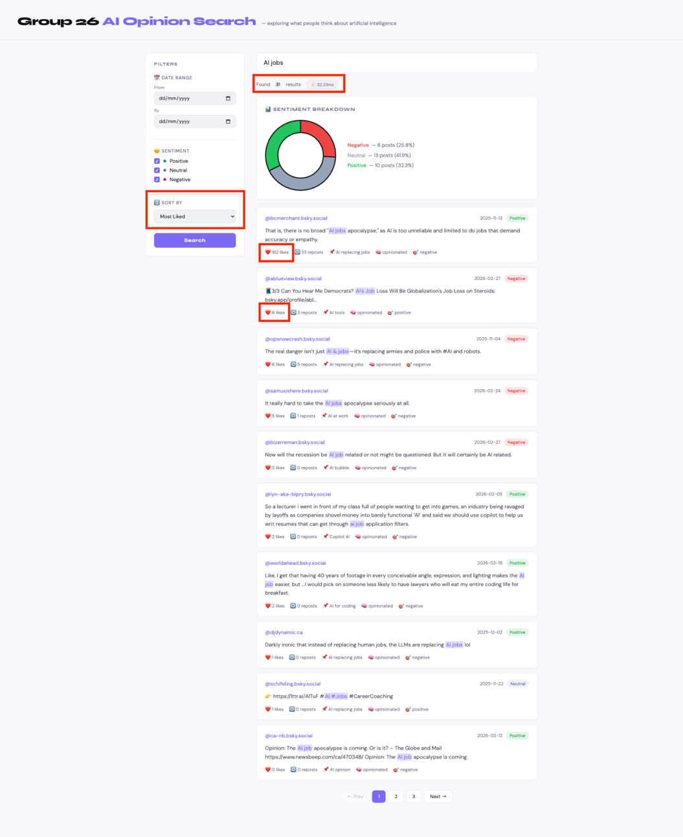
Query 5 searched for "AI jobs" with all sentiment categories selected and sorted by Most Liked, demonstrating the system's ability to surface the most popular opinions with the most liked posts appearing at the top.

